**Roadmap by Simplilearn**

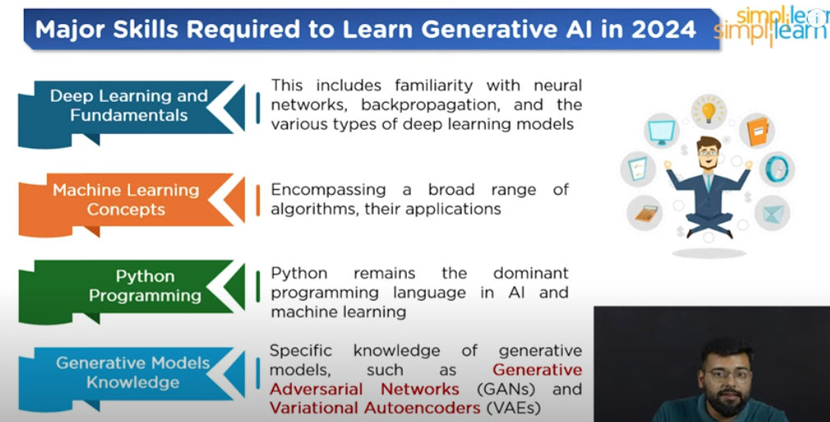

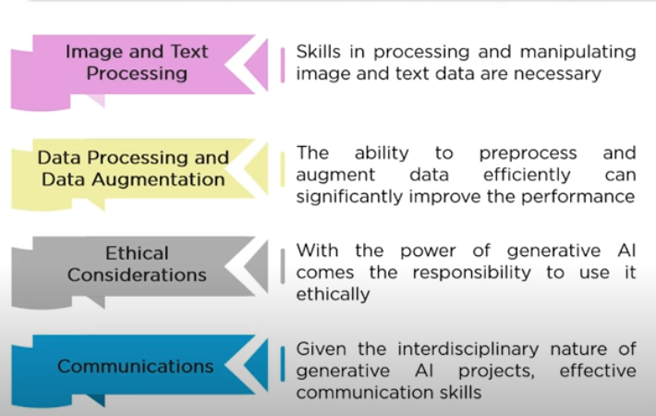

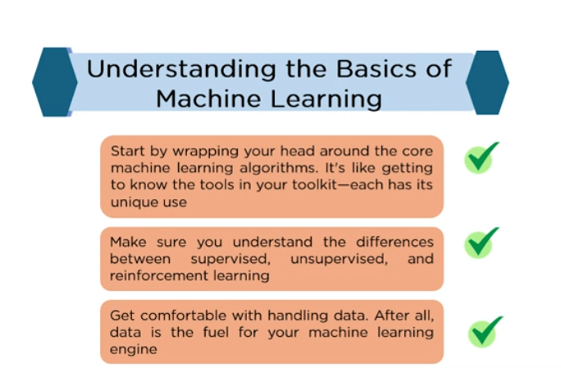

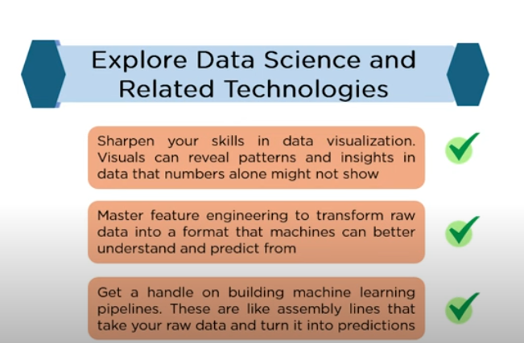

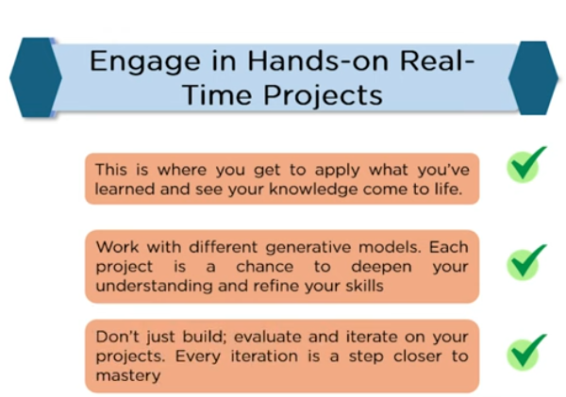

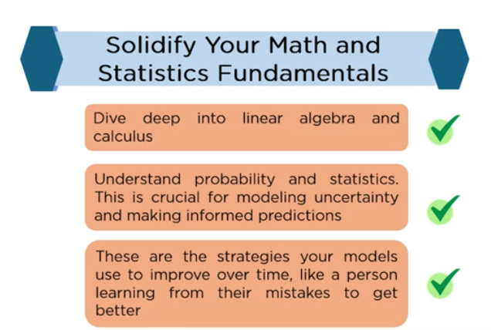

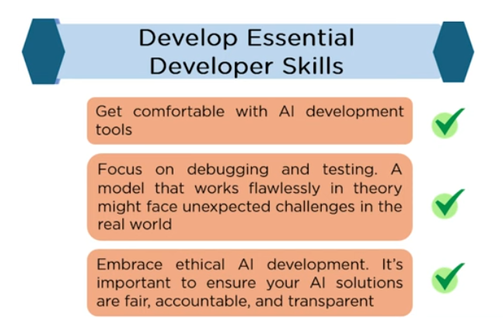

**GenAI roadmap by Krish naik**

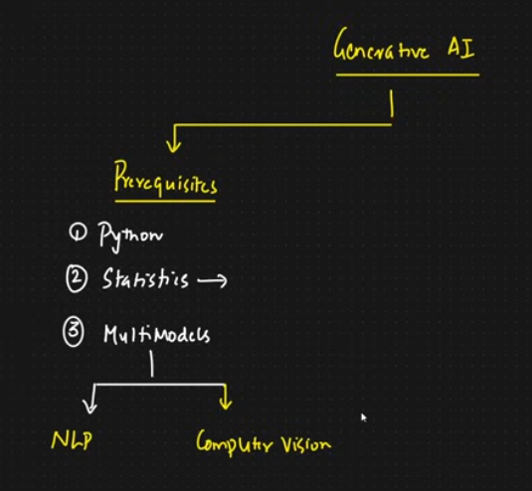

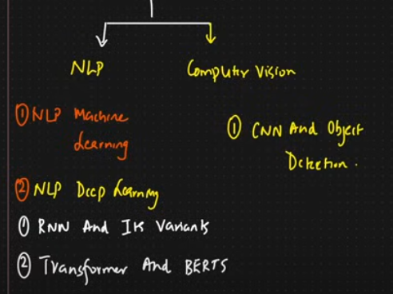

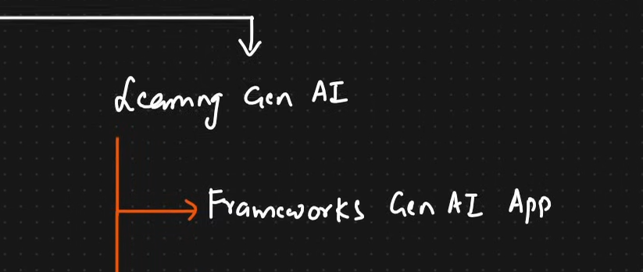

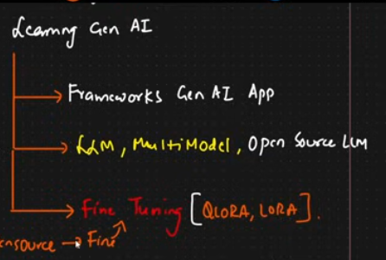

**After doing above if you want to be unique In GenAI so go for MLOPS, LLMOPS**

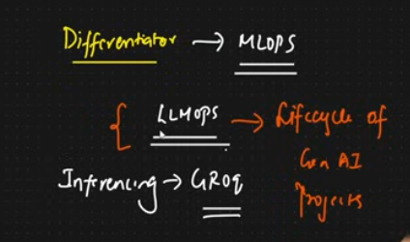

**Then, finally**

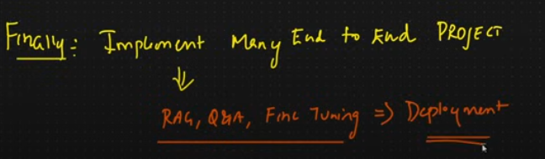

**Old Github link:** <https://github.com/krishnaik06/Roadmap-To-Learn-Generative-AI-In-2024/tree/main?tab=readme-ov-file>

New Github repo: <https://github.com/krishnaik06/AI-Engineer-Roadmap-2024/tree/main?tab=readme-ov-file>

**Irfan Malik**

**AI basic course:** <https://www.youtube.com/playlist?list=PLxf3-FrL8GzTIQpnY_UyzDX6JK0_Kbe_t>

<https://xevenskills.com/courses/free-artificial-intelligence-learning-course/>

Learning outcome:

- Understanding of the fundamentals of artificial intelligence and its various applications.

- Familiarity with popular AI tools like ChatGPT, DALL-E, and Stable Diffusion.

- Proficiency in Python programming language and its data structures, control statements, functions, and classes.

- Knowledge of different types of machine learning, their applications, and the difference between supervised, unsupervised, semi-supervised, and reinforcement learning.

- Understanding of machine learning models, datasets, data preprocessing, training, testing, and evaluation metrics.

- Familiarity with different machine learning frameworks and their usage in creating structured data models.

- Knowledge of data visualization techniques using Matplotlib, Seaborn, and Plotly libraries.

- Familiarity with Hugging Face library and its usage in NLP tasks like text classification, NER, and sentiment analysis.

**Complete Sequence of learning from beginning to advance**

**1. Python for Data Science**

* **Why first?** Python is the primary language for data science and AI. You need to be comfortable with Python and its libraries before diving into data analysis, machine learning, or deep learning.
* **Focus on**: **Pandas**, **NumPy**, **Matplotlib**, and **SciPy**.

**Next Step**: Practice basic data manipulation, analysis, and visualization using Python.

**2. Linear Algebra**

* **Why second?** Linear algebra is the backbone of many machine learning algorithms, especially neural networks. Understanding vectors, matrices, and their operations is crucial before you delve into ML and DL.
* **Focus on**: Matrix operations, eigenvalues, eigenvectors, vector spaces, and transformations.

**Next Step**: Study matrix operations and vector spaces as they apply to data and AI models.

**3. Statistics**

* **Why third?** AI models rely on probability and statistical concepts. You need to understand statistical measures, distributions, and hypothesis testing to evaluate model performance effectively.
* **Focus on**: Descriptive statistics, probability distributions, inferential statistics, and hypothesis testing.

**Next Step**: Learn how to apply statistical tests and build intuition for interpreting data.

**4. Machine Learning (ML)**

* **Why fourth?** With Python, linear algebra, and statistics in place, you're ready to explore how data is used to train models. Start with traditional ML algorithms before moving to deep learning.
* **Focus on**: Regression, classification, clustering, decision trees, support vector machines, and model evaluation.

**Next Step**: Implement machine learning models using libraries like **Scikit-learn**.

**5. Deep Learning (DL)**

* **Why fifth?** Deep learning builds on machine learning but requires a deeper understanding of neural networks. Your background in linear algebra will help grasp the structure of neural nets.
* **Focus on**: Neural networks, backpropagation, optimization, CNNs, RNNs, and LSTMs.

**Next Step**: Learn to implement models using **TensorFlow** or **PyTorch**.

**6. Generative AI (Gen AI)**

* **Why last?** Generative AI is the most advanced topic. You'll need knowledge of deep learning to understand the architectures behind models like GANs, VAEs, and Transformers.
* **Focus on**: GANs, VAEs, GPT, diffusion models, and multimodal models like DALL-E.

**Next Step**: Start with simpler generative models like VAEs and GANs, and gradually move to large language models (LLMs) and more complex systems.

Check description of this video for some resources: <https://www.youtube.com/watch?v=mkRVHLQmsp4>